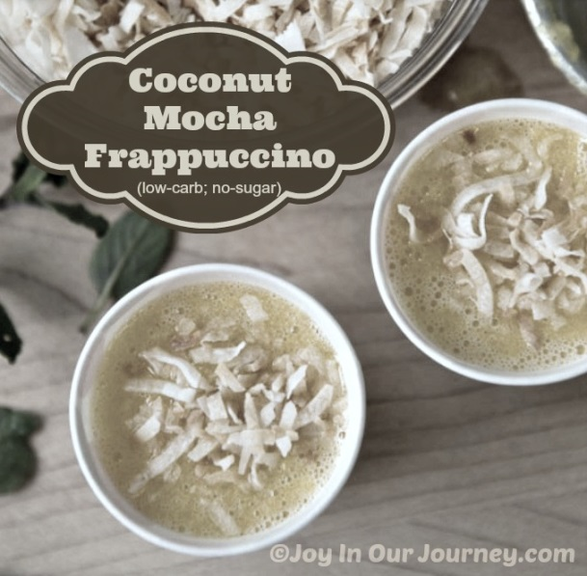
Coconut Mocha Frappuccino
(low-carb; no-sugar)

Recipe by Julieanne at Joy In Our Journey.com

A Coconut Mocha Frappuccino is just what I want to have when I'm craving for more complex tastes and textures in a protein-filled frozen blended beverage!
Here's the recipe for two large servings:
- 2 cups almond milk
- 1/2 cup chilled coffee + optional 2 tsp. coffee extract (directions to make your own, here)
- 1-2 scoops vanilla whey protein powder (no sugar added)
- 4 cups ice cubes
- 2 strips Lily's Chocolate (no sugar) or 2 squares Lindt 90% chocolate (contains small amount of sugar)
- 1 cup unsweetened flaked coconut*; toasted or untoasted
- 2 tsp. vanilla extract
- 1/4 tsp. Celtic salt, Himalayan salt, or Redmond RealSalt
- 2 small shakes powdered stevia extract, or to taste
- 1/2 tsp. glucomannan powder or xanthan gum (optional - to improve texture)
- 2 Tbsp. non-GMO erythritol or xylitol
Toasted coconut has the same flavor as untoasted coconut, but it also has a caramelized nuttiness and a crisp-chewy texture that raw coconut doesn’t offer. It’s easy to toast unsweetened, flaked coconut at home!
Oven: spread shredded coconut in a thin layer on a baking sheet. Bake at 300° F for about 20 minutes, stirring every 5 minutes to make sure that the coconut browns evenly.
Stove top: spread shredded coconut into a skillet and cook over medium heat, stirring frequently, until coconut is mostly golden brown.
Microwave: spread some coconut in a thin layer on a glass/Pyrex pie plate or microwave-safe plate; cook on high, stirring the coconut every 30-45 seconds to ensure that it browns evenly and doesn’t scorch. Depending on how much coconut you’re toasting, you should be done in less than 3 minutes. Stick with small amounts of coconut with the microwave method, and watch closely so it doesn't burn.
Place all ingredients into blender (halve the recipe if your blender won't handle this much at once). Blend well. Add additional sweetener, ice, or almond milk for your desired sweetness and thickness. If desired, sprinkle tops of frappuccinos with toasted coconut or a dusting of cocoa powder.
*Note: By following these directions, you'll still have the texture of flaked coconut in your frappuccino, even using a Vitamix. If you prefer a smoother texture, place unsweetened, untoasted coconut into a food processor and blend until "butter" is formed; this usually takes several minutes.

© Julieanne at Joy In Our Journey.com (2014)

