Low Carb Swirled Cheesecake Brownies
These delicious guilt-free brownies are low carb and gluten-free.
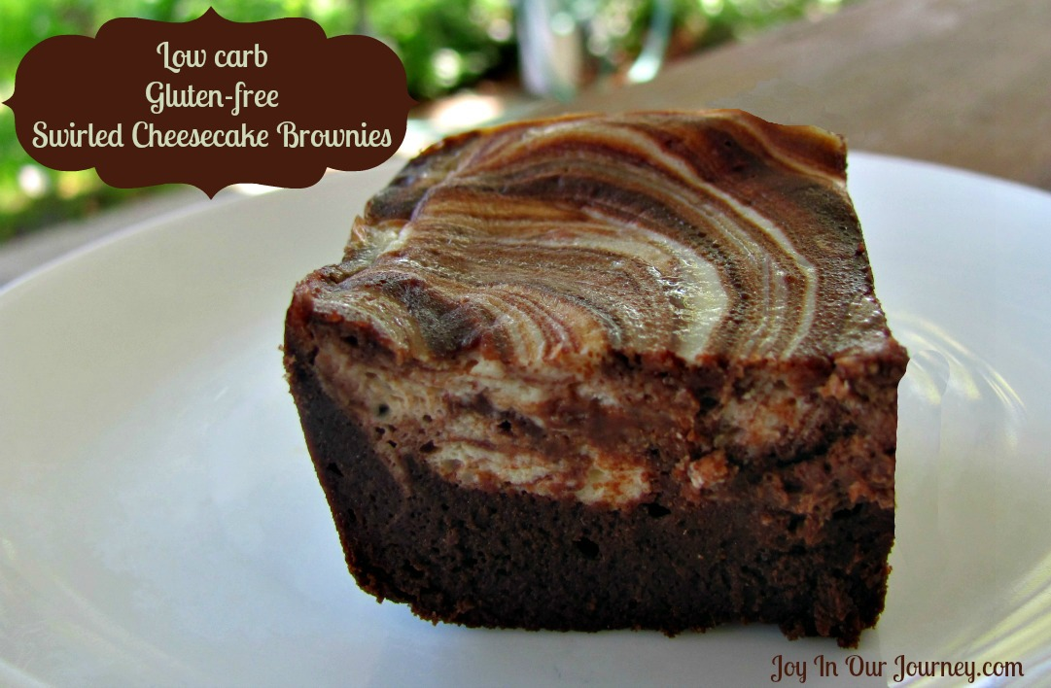
Serves: 16 Serving Size: 1 brownie
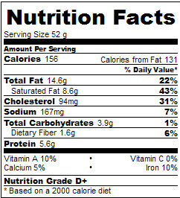
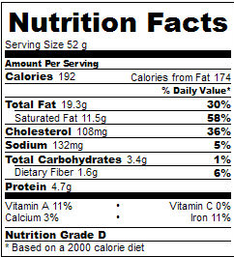
Nutrition facts for full fat cream cheese
Brownie layer:
- 12 Tbsp. (1½ sticks) butter
- 4 oz. unsweetened chocolate
- ¼ cup unsweetened cocoa powder
- ½ cup erythritol, powdered (can use a clean coffee grinder)
- ¼ cup xylitol, powdered
- ½ tsp. vanilla
- 5 large eggs

Cheesecake layer:
Nutrition facts for nonfat cream cheese
- 8 oz. cream cheese or nonfat cream cheese, softened
- ¼ cup erythritol sweetener (powdered)
- 1 large egg
- 1 tsp. vanilla

Preheat oven to 350° F. Grease an 8 x 8” metal baking pan. In a large bowl, beat powdered erythritol and softened cream cheese until smooth. Add 1 egg and 1 tsp. vanilla and beat well until combined. Set aside.

For the brownie layer, melt butter, unsweetened chocolate, and cocoa powder together in a small to medium saucepan; stir until smooth. Add in erythritol, xylitol, and vanilla. Stir well and let cool for five minutes. Add eggs one at a time, whisking well, until combined. Spread brownie mixture in greased pan. Spoon cheesecake layer over the top of the brownies; use a knife to swirl the two layers together, bringing some of the brownie mixture to the top. Bake 20-30 minutes, until sides are well set and the middle wobbles just a little bit. Remove pan from oven; let cool for 20 minutes. Then refrigerate until brownies are set, about two hours, or overnight.

Why does this recipe receive a Nutrition Grade of D or D+? USDA guidelines consider eggs to be fattening and not so healthy…but we all know that eggs are God’s best source of protein and contain so much that we need to have healthy bodies! Feel free to enjoy this for breakfast; just be sure to not add a carby side to this meal.

