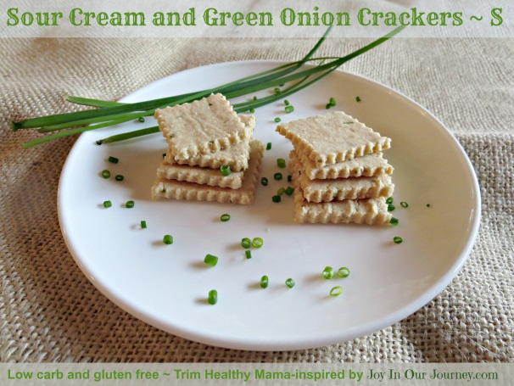
Sour Cream and Onion/ Chive Crackers (S)
- 4 cups almond flour (I love the Honeyville brand for being finely ground)
- 1.4 oz or 40 grams green onion stems or fresh chives
- 1/2 cup + 2 tsp. full fat sour cream (I love the Daisy brand - no chemicals!)
- 1-1/2 tsp. unrefined sea salt or to taste (Redmond RealSalt is wonderful)
- 1 tsp. garlic powder

Preheat oven to 250° F (100° C). Holding a small bunch of green onion tops or chives, use kitchen scissors to snip them into very small pieces, or use a knife to slice them thinly. In a medium bowl, combine all ingredients with your hands or a heavy spoon. Knead dough until smooth, approximately 30-60 seconds. Divide dough into two balls.
Place each ball of dough on a separate baking sheet lined with parchment paper or a Silpat silicone baking mat. Cover each dough ball with a piece of parchment paper. With a rolling pin, roll the dough as thin as you can - the thinner the dough, the crisper the cracker. Remove the top parchment paper.
Cut the dough into 1" or 2" squares with a knife, pizza cutter, or pastry wheel. The pastry wheel does a nice job of giving the crackers that zig zag look. ☺ I use my grandmother's 80-year-old pastry wheel.

Place baking sheets in the oven and bake for 50-60 minutes, checking several times so make sure the crackers don't get too brown or burn. Cool completely and break into squares.
After crackers have cooled, store them in airtight containers or Ziplocs. They will stay crisp for at least 4-5 days...if they last that long!

$©$ 2014 ~ Julieanne Miller ~ Joy In Our Journey.com

