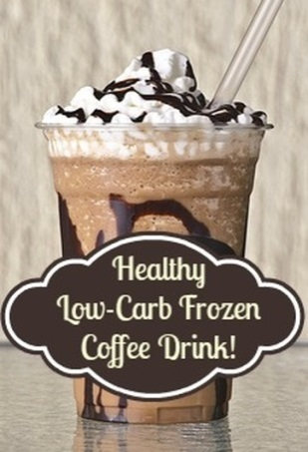
Healthy Low-Carb Frozen Coffee Drink (single serving)
- 4 tsp. erythritol or no-sugar sweetener of choice
- 1/16 tsp. pure stevia extract powder (or to taste)
- 1 Tbsp. unsweetened cocoa powder
- 2 tsp. mesquite powder (optional)
- 3 oz. cold coffee
- 3 Tbsp. organic half and half
- 1/4 tsp. vanilla extract
- 1 cup crushed ice
- tiny pinch or sprinkle of salt
- 1/32 tsp. xanthan gum (for a "creamier" texture)
Combine dry ingredients. To blender or Magic Bullet, add crushed ice, water, half and half, and vanilla extract. Add dry mix to blender. Blend until smooth. Pour into glass. Optional: top with stevia-sweetened whipped cream and sugar-free chocolate syrup.
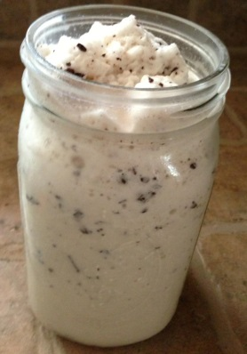
Peanut Butter Chocolate Chip Frappa (THM-style)
- 2 cups almond milk
- 3 Tbsp. no-sugar-added peanut butter (salted)
- ¼ tsp. salt
- ½ tsp. xanthan gum
- stevia to taste
- 1 scoop vanilla whey protein powder
- 3/4 jar??? of ice
- 1/3 oz. 85% chocolate

Add all ingredients to blender in the order listed, except for the 85% chocolate. Combine well and add 85% chocolate to blend briefly.
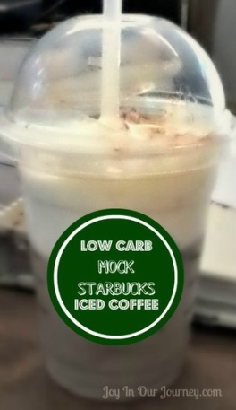

Perfect Low-Carb Mock Starbucks Iced Coffee!
- fresh ground coffee beans
- ice
- chocolate extract
- Torani sugar-free vanilla syrup (if desired) or pure vanilla extract or
- Totonac stevia-sweetened vanilla syrup
- chocolate liquid stevia, if desired
- heavy cream
- cocoa powder
Make one strong cup of coffee in a French Press. Pour a little under 2/3 of the coffee in a large cup that has been completely filled with ice to cool it down. Remove about half of the ice once it is cold, and pour the coffee and remaining ice into the cup you'd like to serve your iced coffee in. Grind one heaping scoop of coffee and put it in the French Press with the remaining coffee. Wait 3 minutes; then, press down the French Press' handle and filter to make the coffee. Combine the ultra-strong coffee with the first cup of coffee. Add about 1/8 - 1/2 tsp. or to taste of chocolate extract, vanilla or vanilla syrup to taste, 4-8 drops chocolate liquid stevia, about 1-4 Tbsp. heavy cream to taste, and the ultra-strong coffee. Mix with a straw, stir stick, or spoon. Top with whipped cream and dust with cocoa powder.

