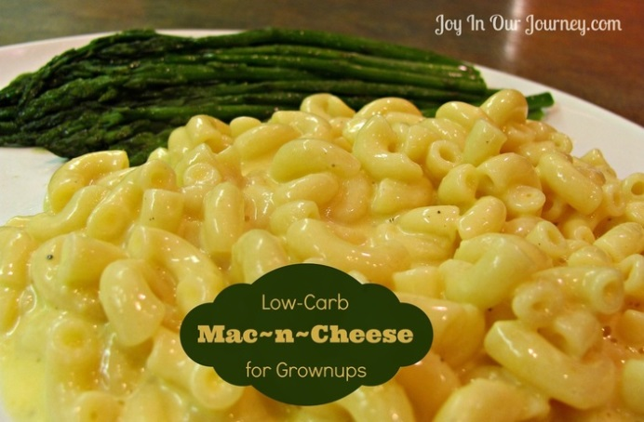
Low-Carb Mac 'n Cheese
for Grownups
(S meal for those following the
Trim Healthy Mama lifestyle eating plan)
- 13.25 oz. Dreamfields elbow macaroni pasta
- 1½ tsp. salt + ½ tsp. additional salt
- 2 large eggs
- 6 oz. cream
- 6 oz. water
- 1 tsp. dry mustard, dissolved in 1 tsp. water
- ¼ tsp. Tabasco or hot sauce
- ¼ tsp. black pepper
- 4 Tbsp. (½ stick) unsalted butter
- 12 oz. (3 cups) shredded cheddar cheese
Bring 2 quarts water to boil in a large pot for the macaroni. Stir in 1½ tsp. salt and the macaroni and cook according to package directions (cook no longer than stated on package directions).
Meanwhile, mix together the eggs, 3 oz. of cream, the mustard mixture, Tabasco (or hot sauce), ½ tsp. salt, and 1/4 tsp. pepper. Whisk well.
Drain the cooked pasta and return it to the pot. Set the pot over low heat and stir in the butter until melted.
Stir in the egg mixture and half of the cheddar cheese. Continue to cook over low heat, gradually stirring in the remaining cream, water, and cheddar cheese, until the mixture is hot and creamy, about 5 minutes. Season with salt, pepper, and additional Tabasco or hot sauce, to taste. Serves 5.

©2014 Joy In Our Journey.com

